Free Text Queries (Ranked Search)
- “Cotton Shirt”: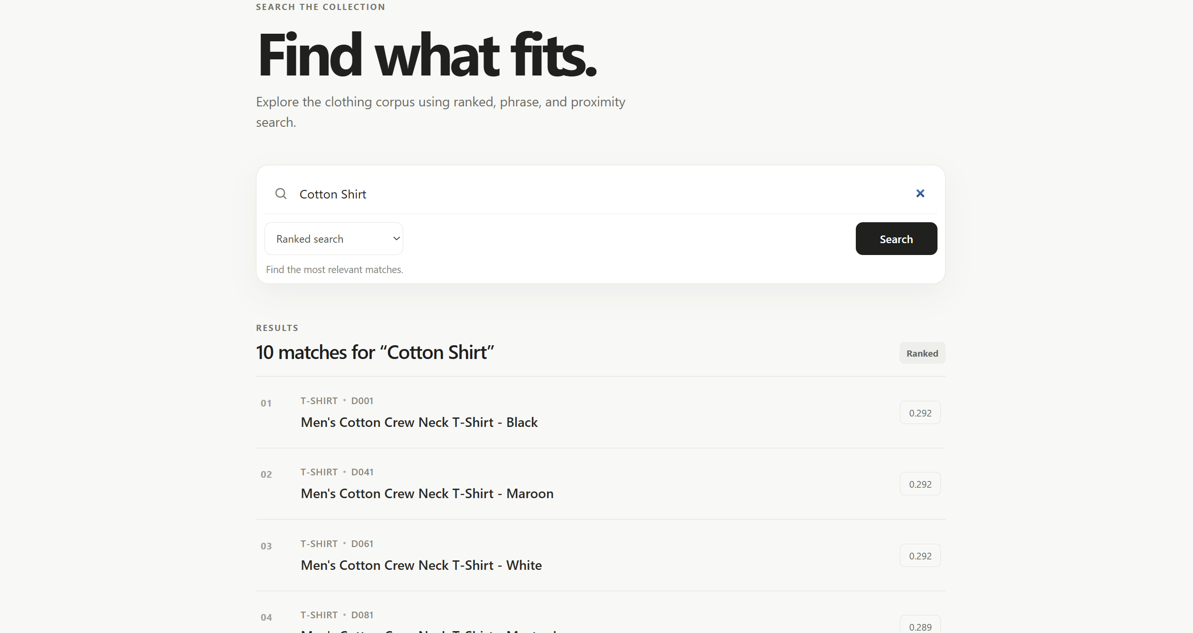
- “Jeans Denim”: 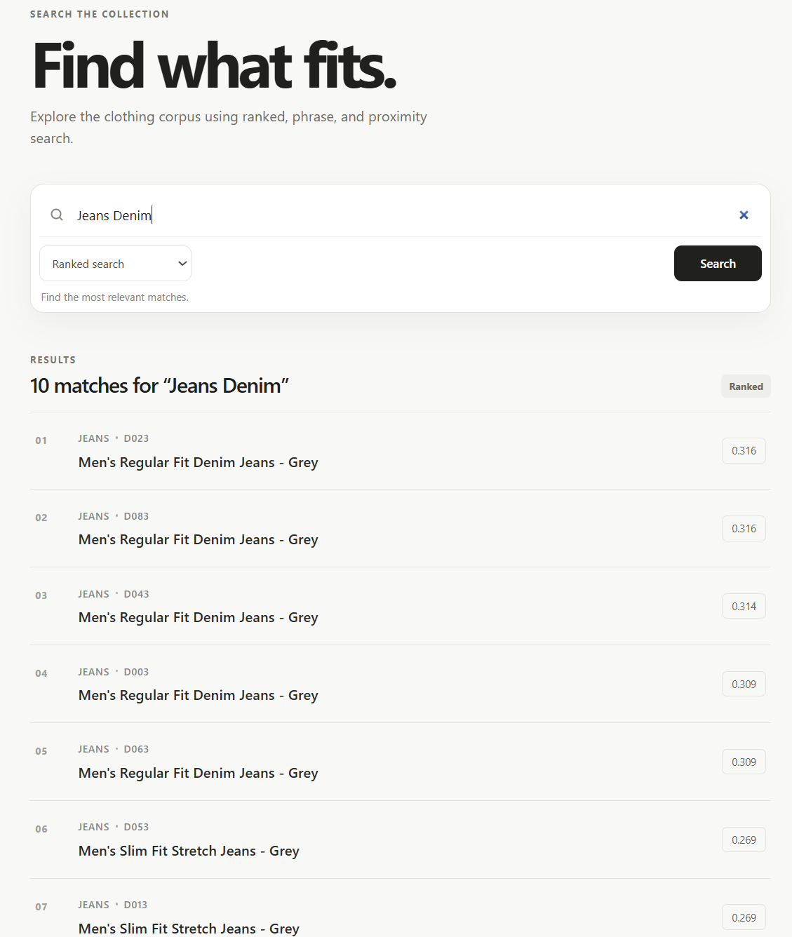
- “Black Winter Wear”: 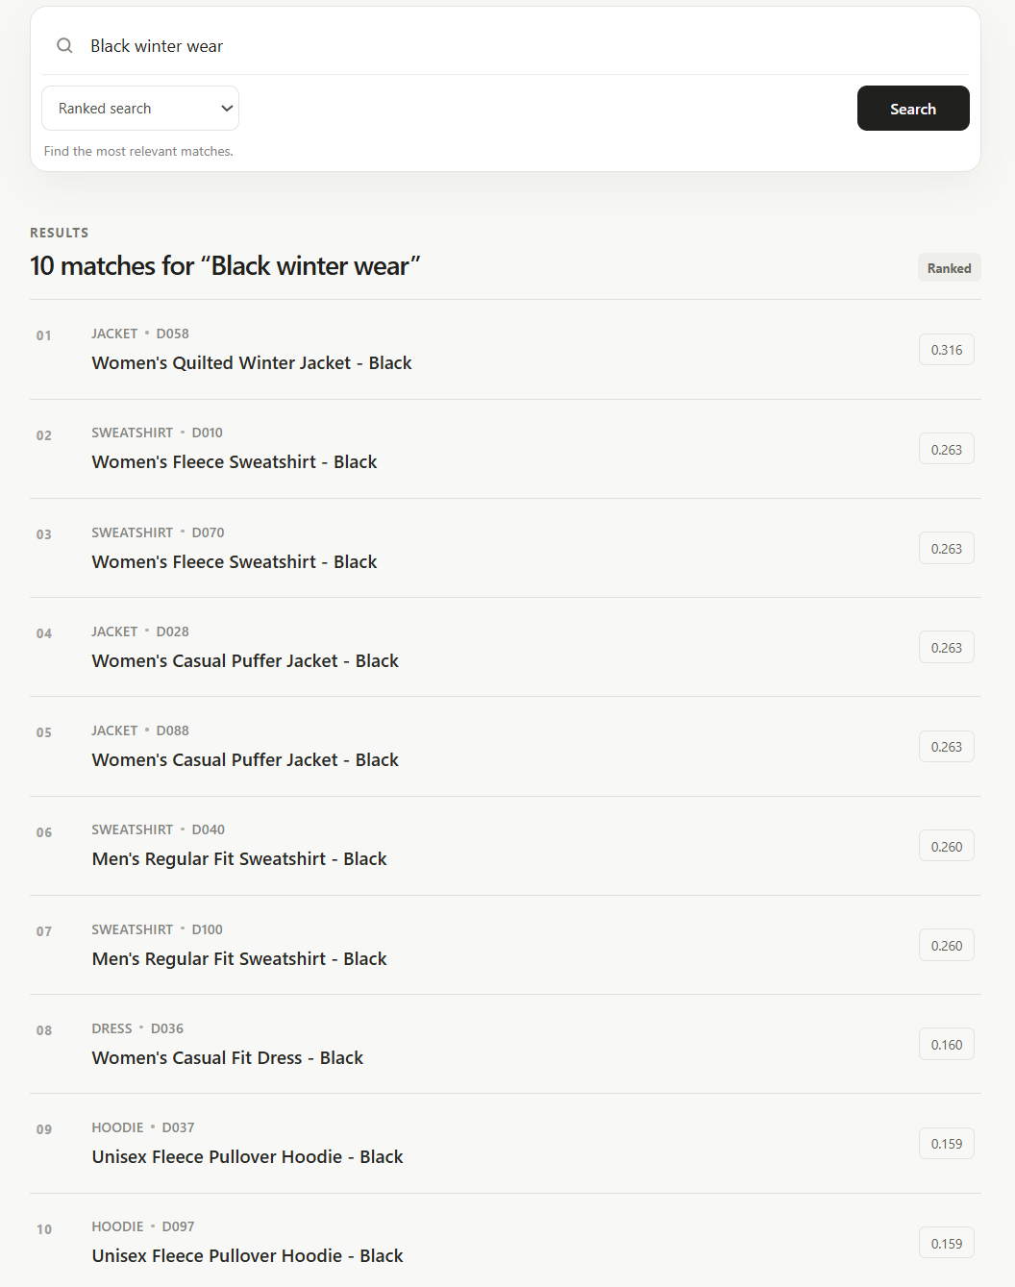
- “Unisex Jacket Blue”: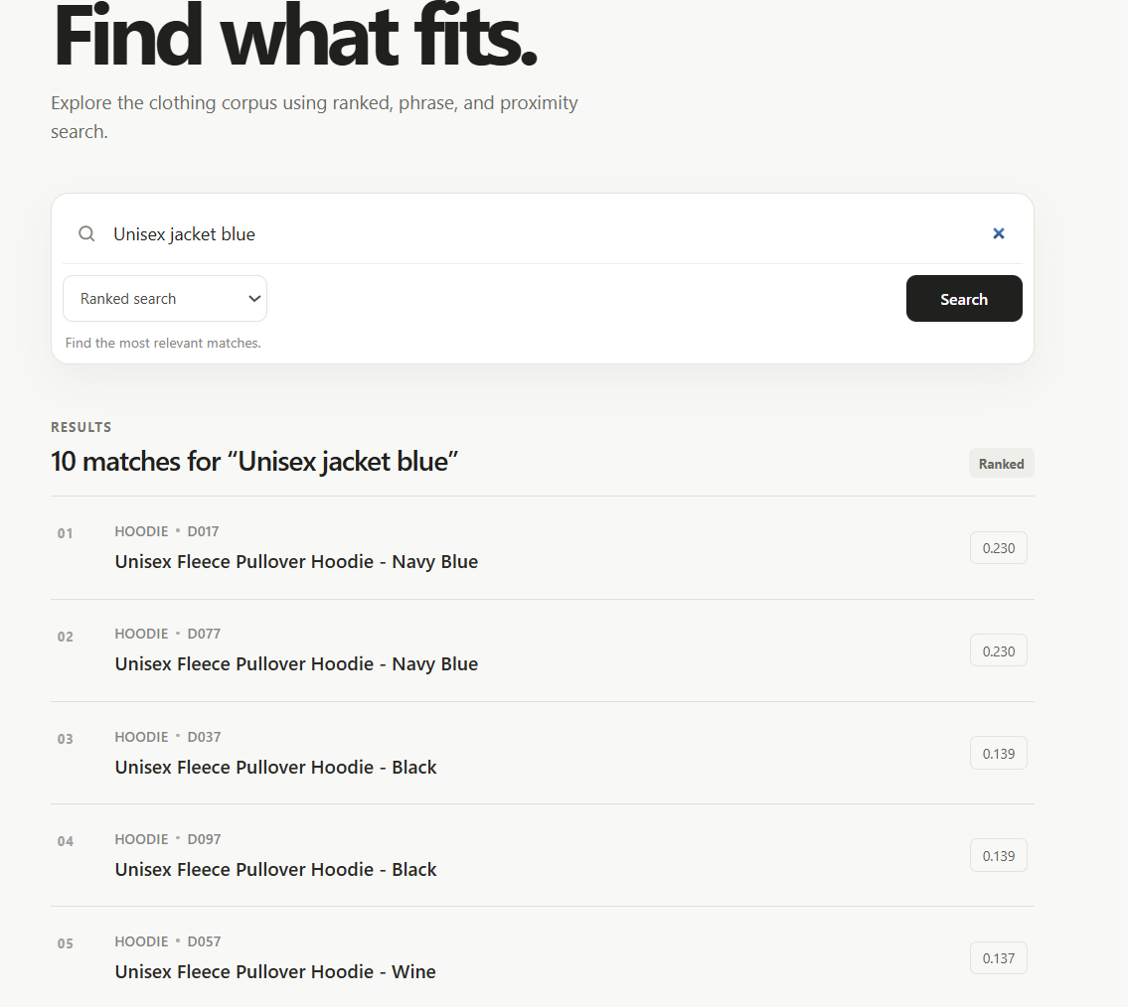
- “breathable jeans for men stretch fit”: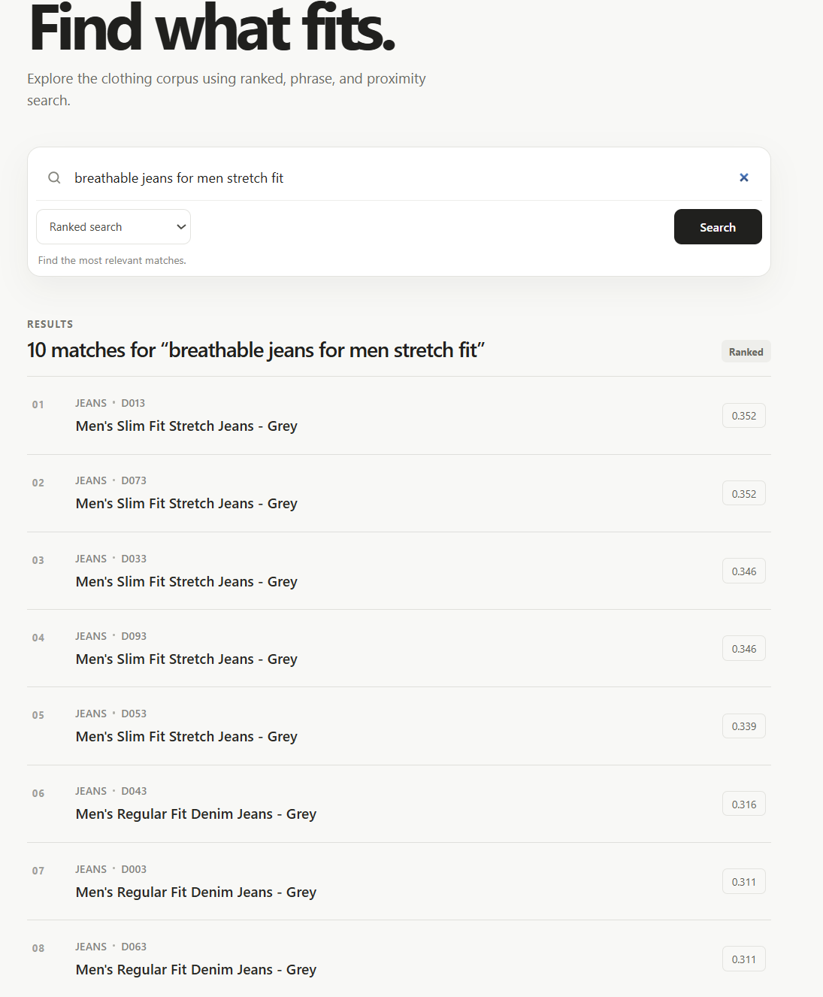
- “Men’s loose kurta”: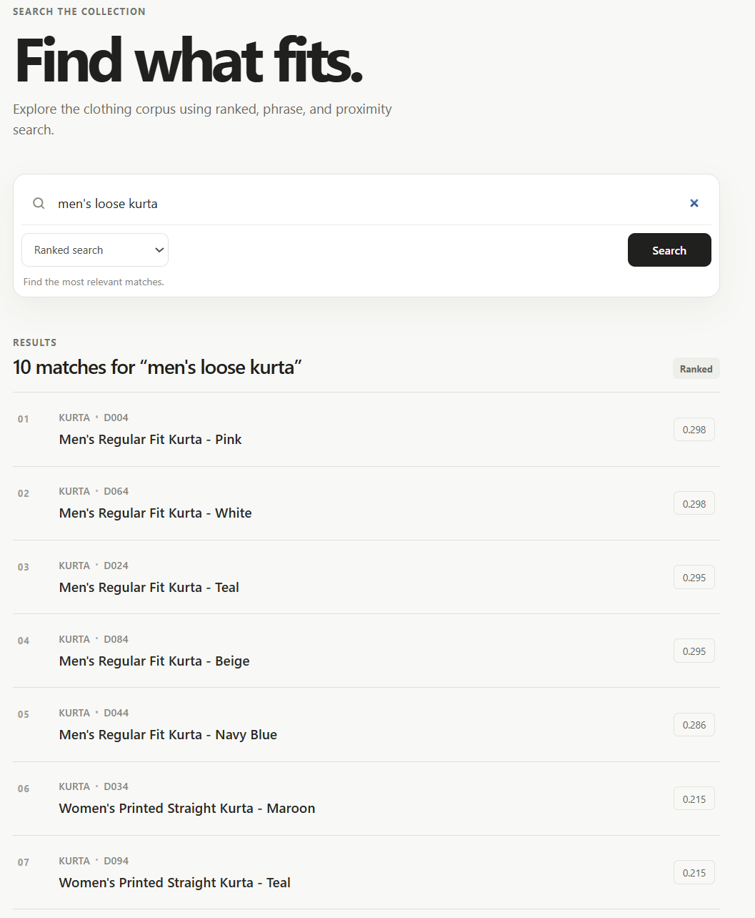
- “Olive jackets for women”: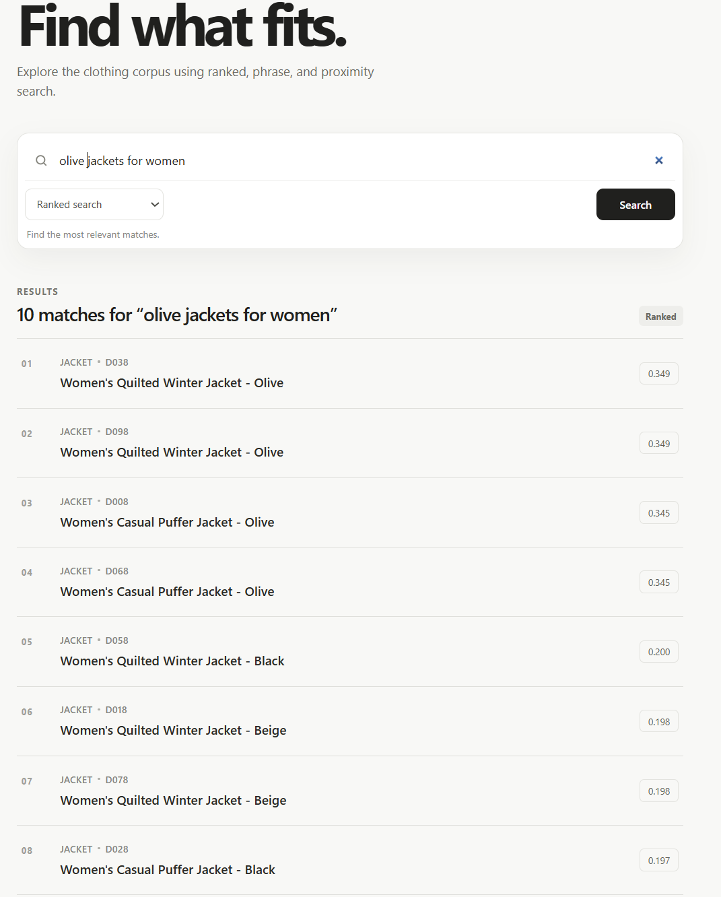
- “kurta”: 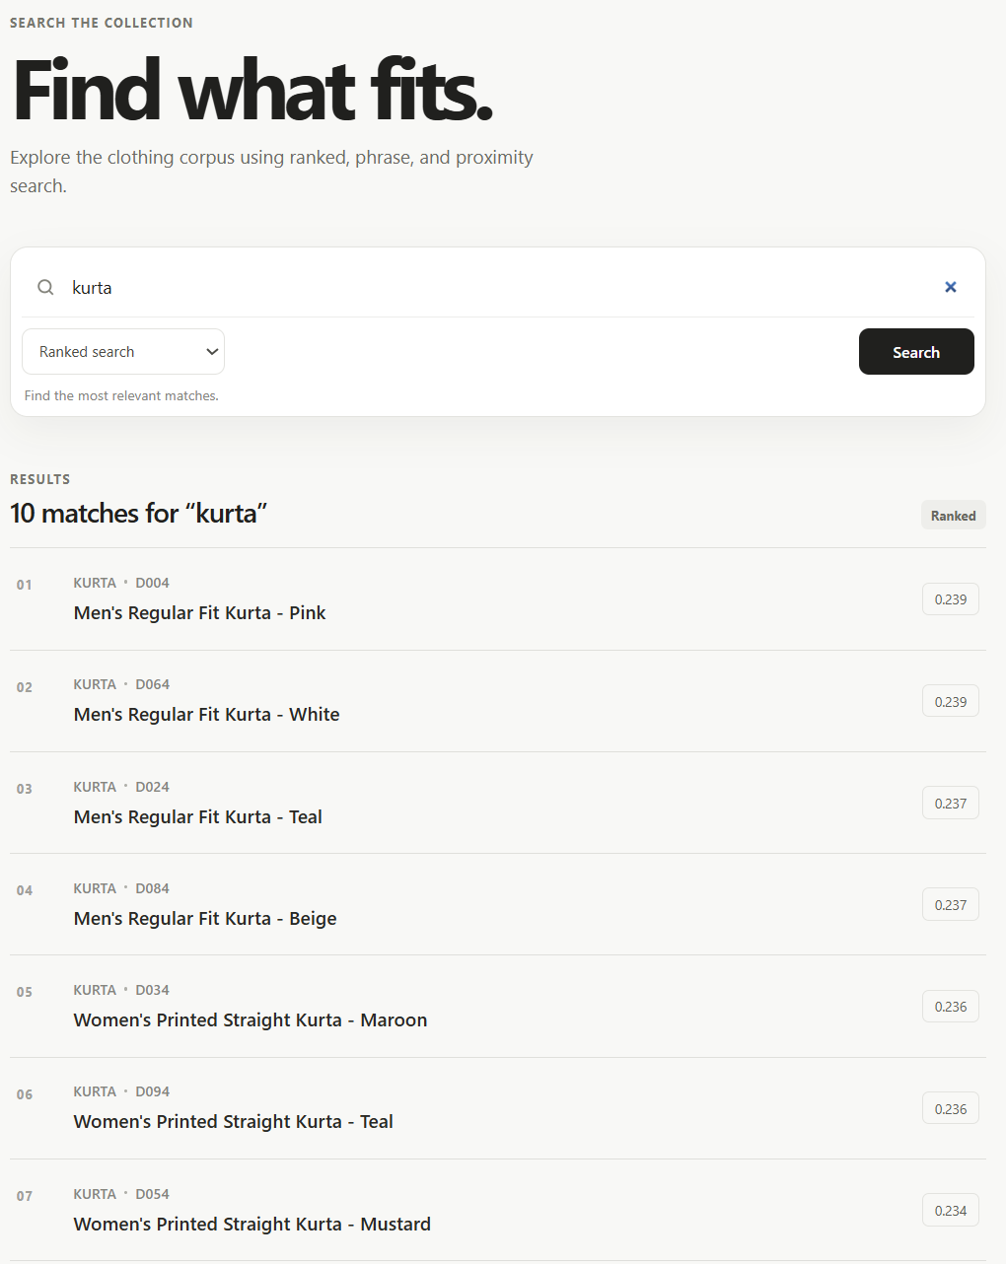
- “Beige Clothing for women”: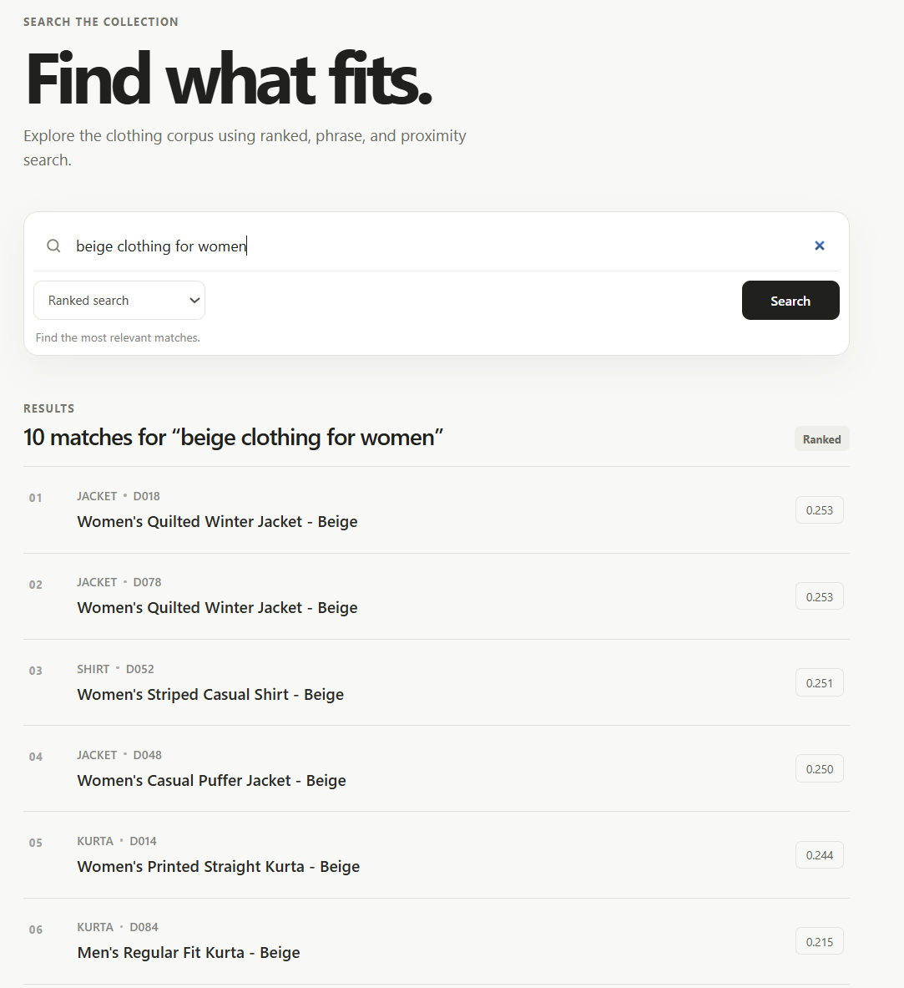
- “Beige clothing for men”: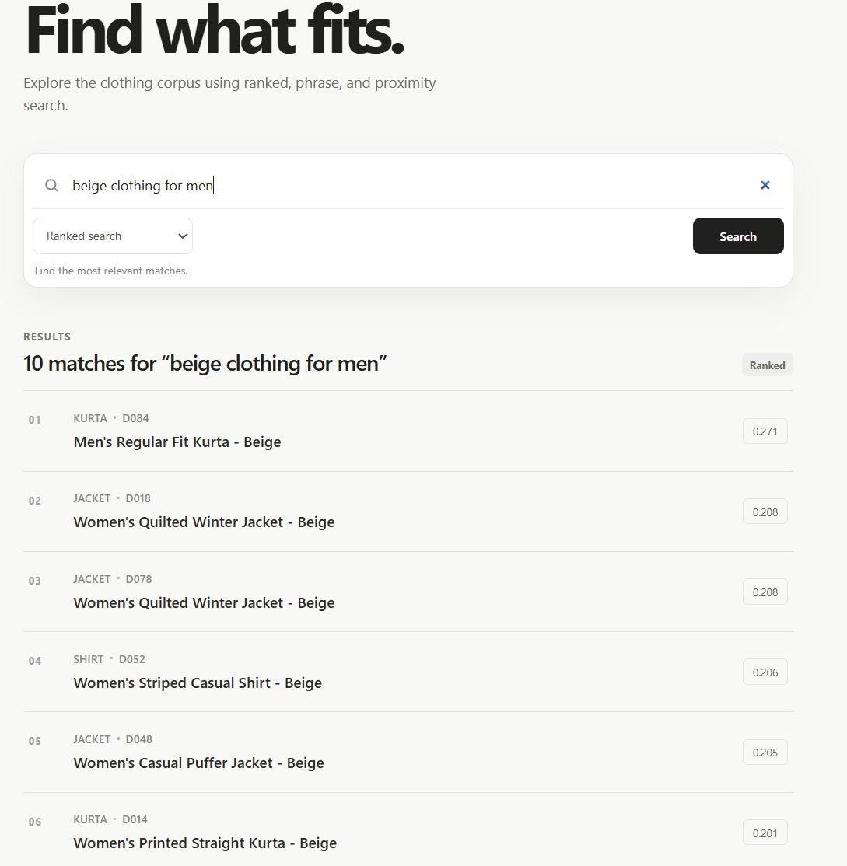

Phrase Query Testing
- “Cotton Shirt”: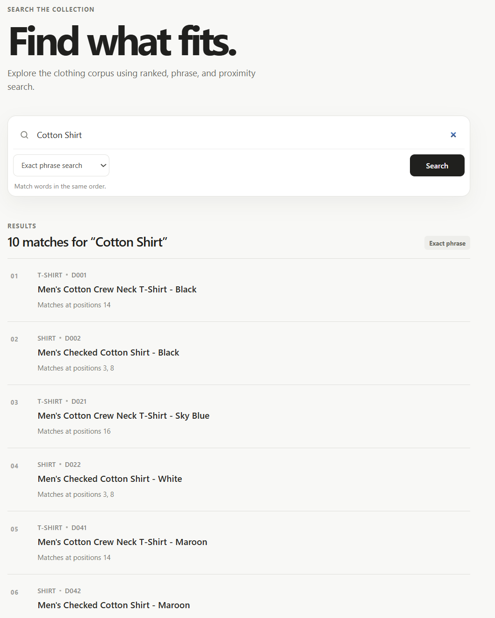
- “Stretch Denim”: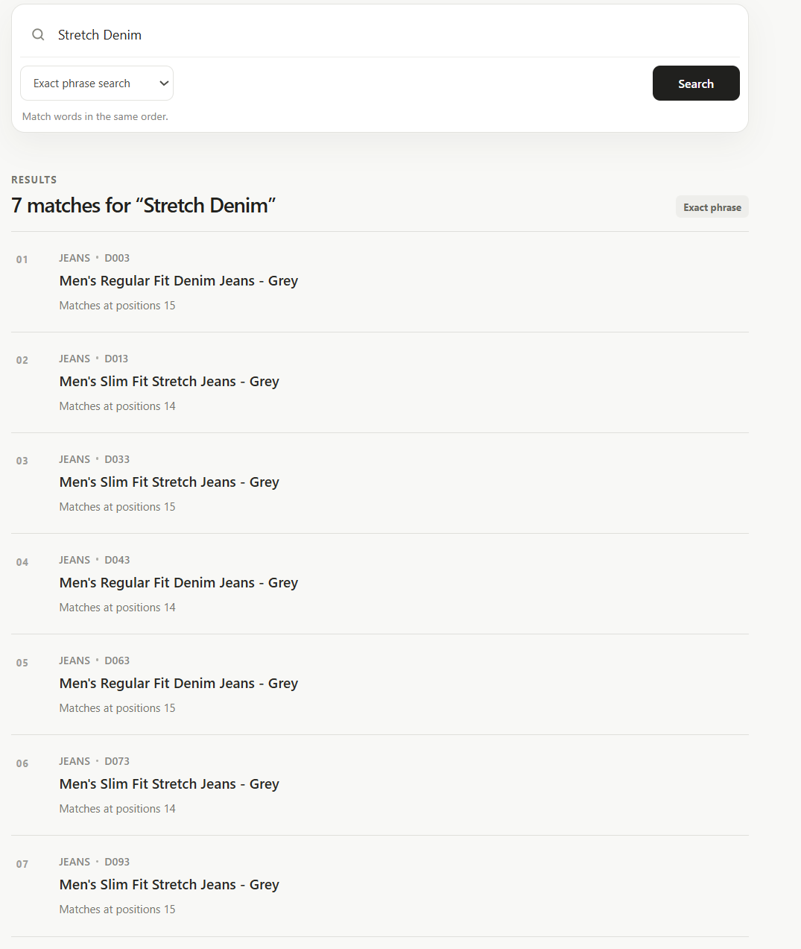
- “Festive wear”: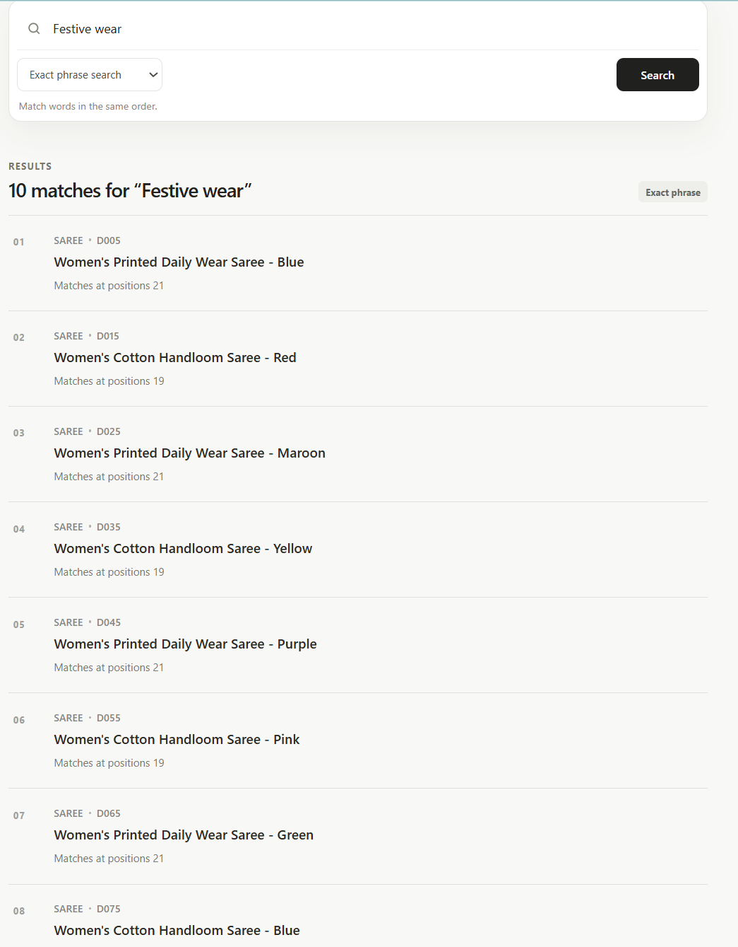
- “Winter Wear”: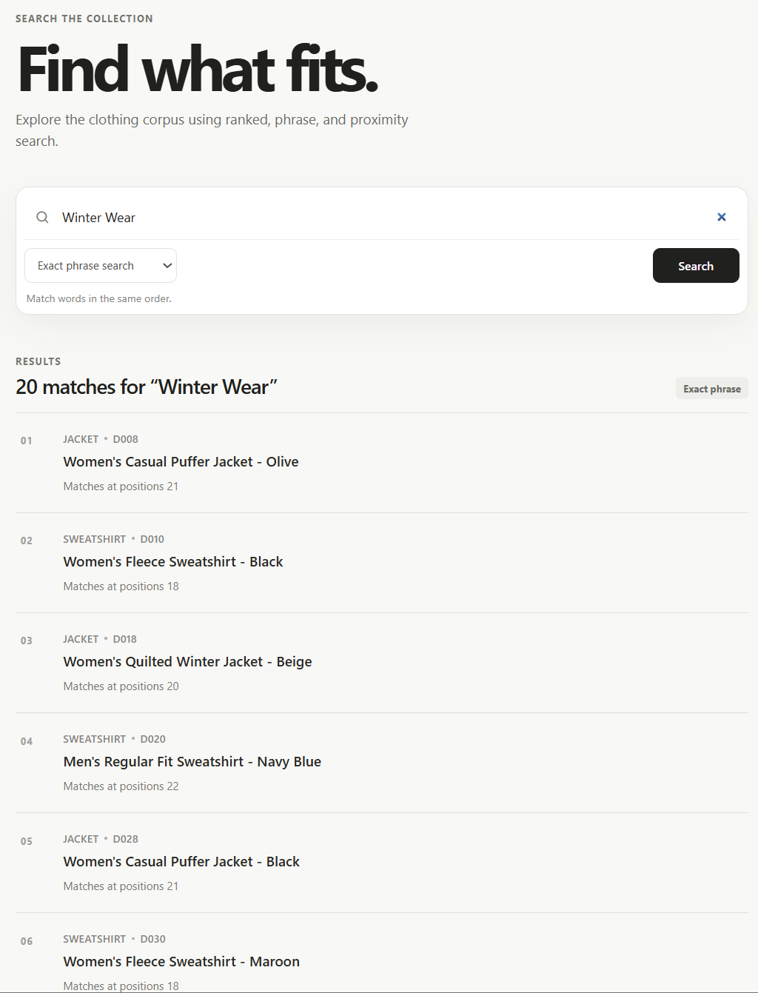
- “Regular Fit”: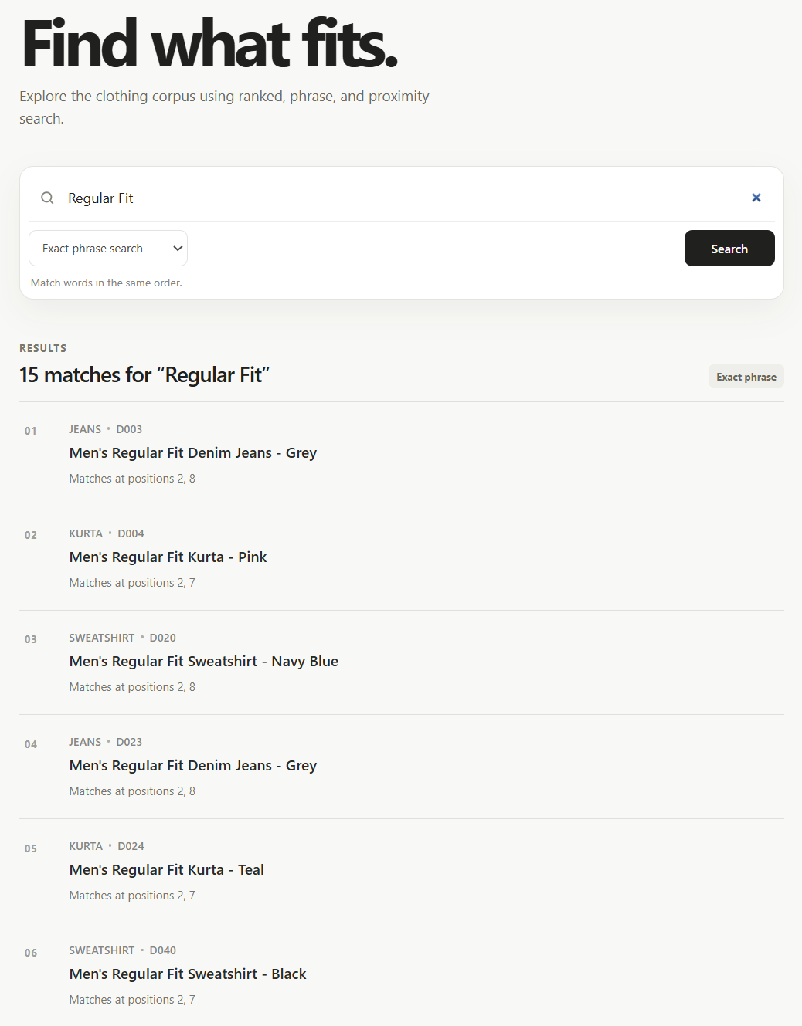

Proximity Query Testing
- “Cotton WITHIN/k shirt”:
  - K=3: 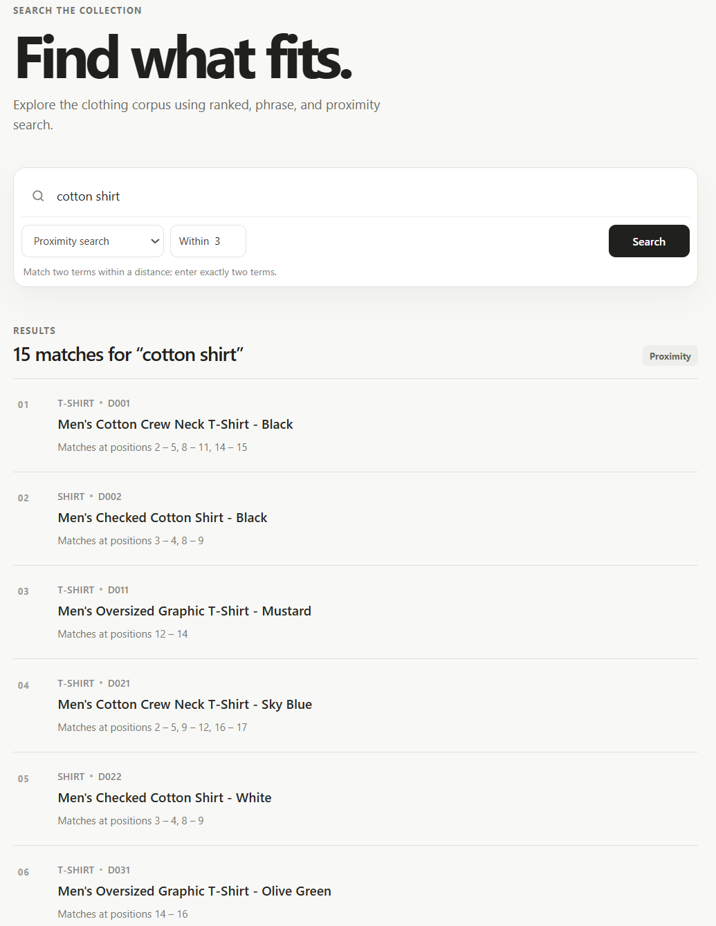
  - K=2: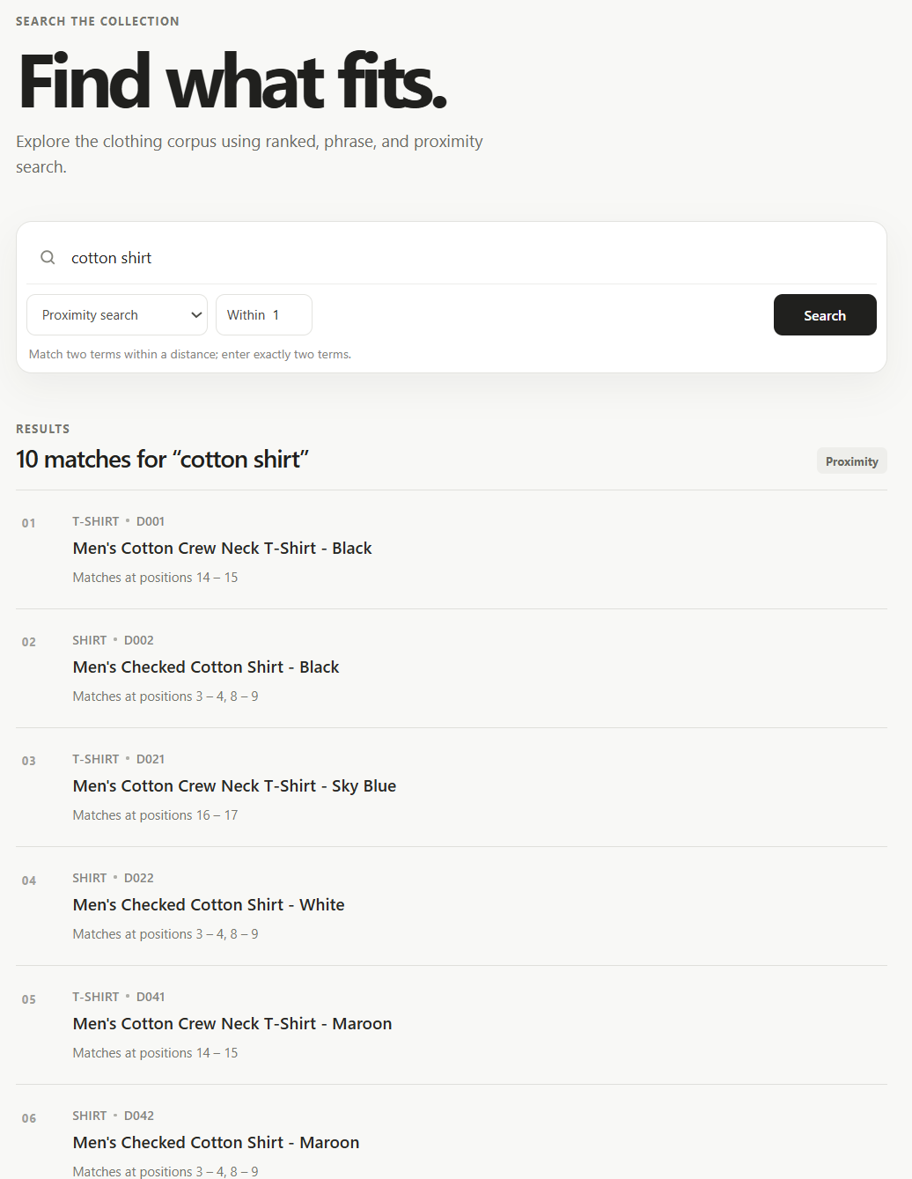
  - K=5: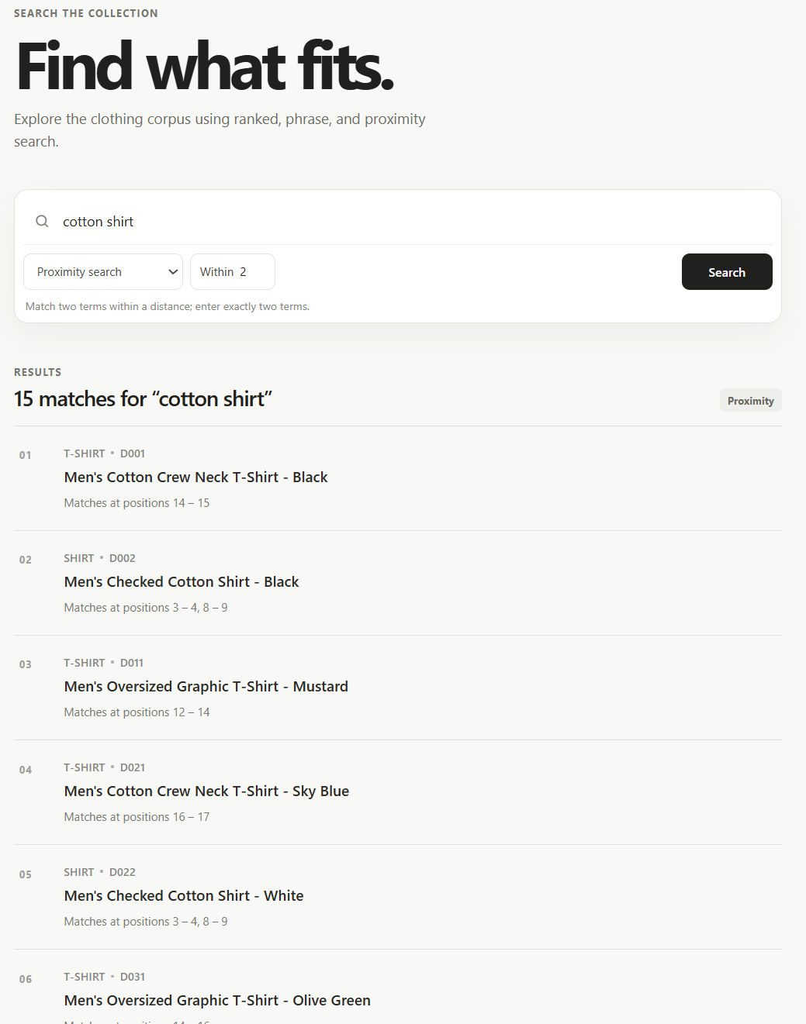
- “Stretch WITHIN/k denim”:
  - K=1: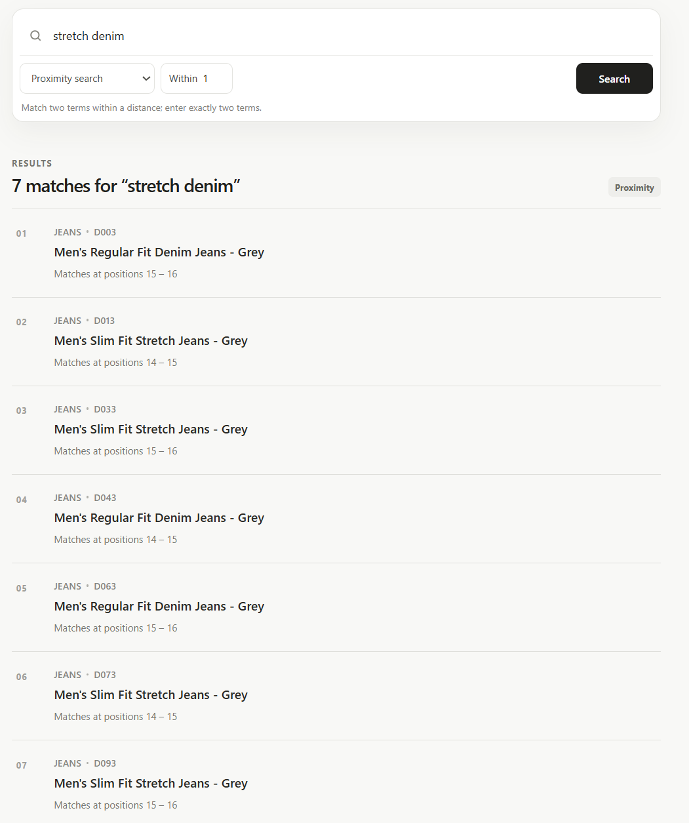
  - K=3: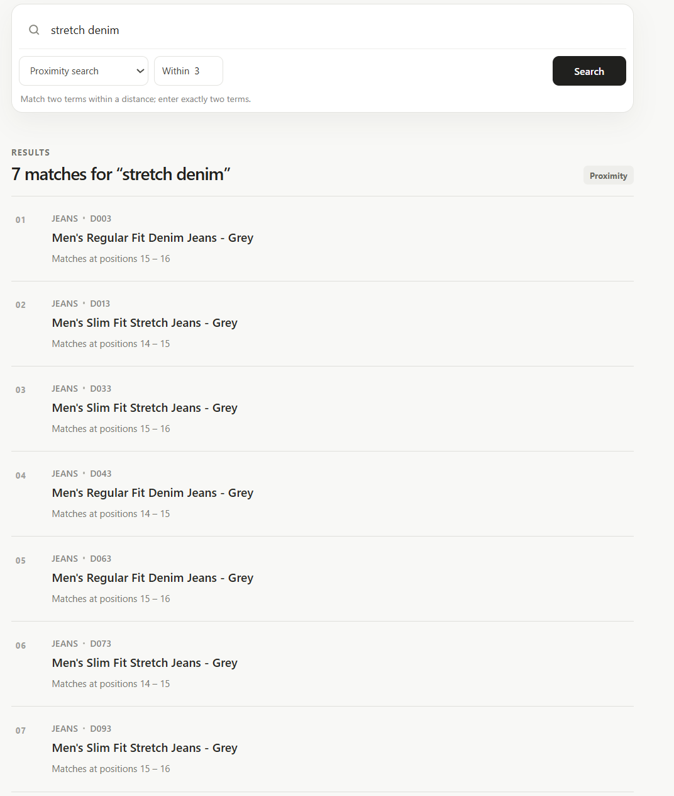
  - K=7: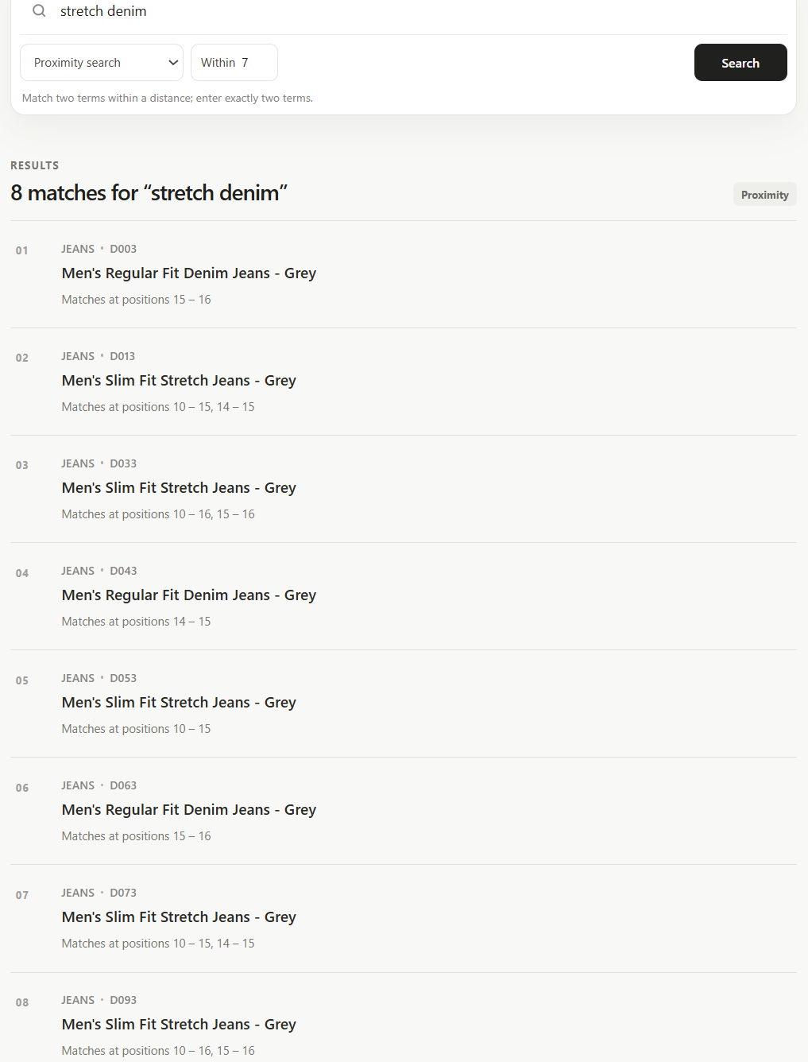
- “comfortable WITHIN/k wear”:
  - K=1: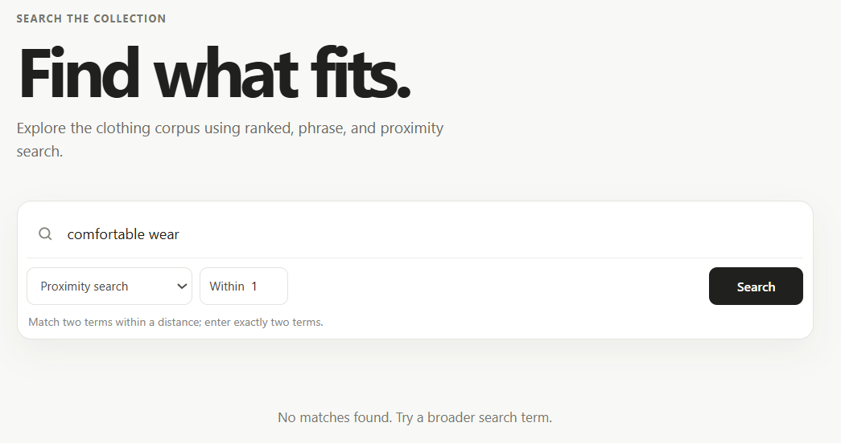
  - K=5: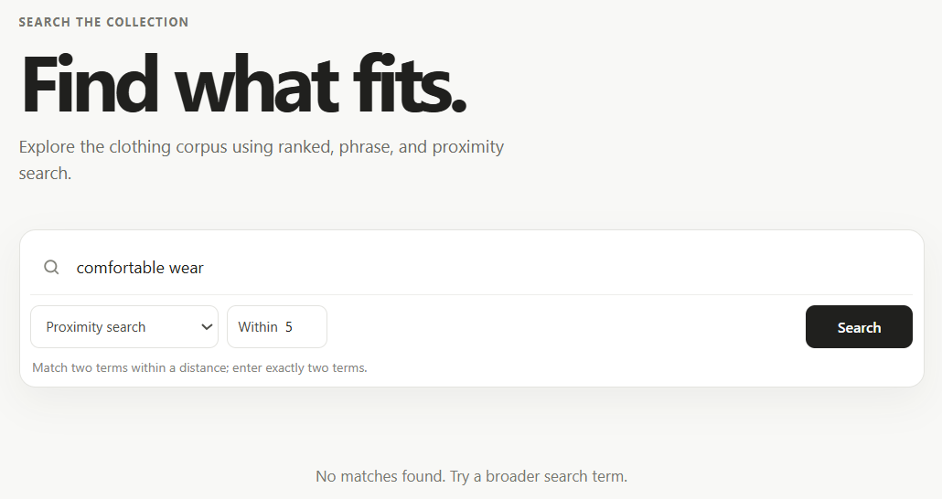
  - K=10: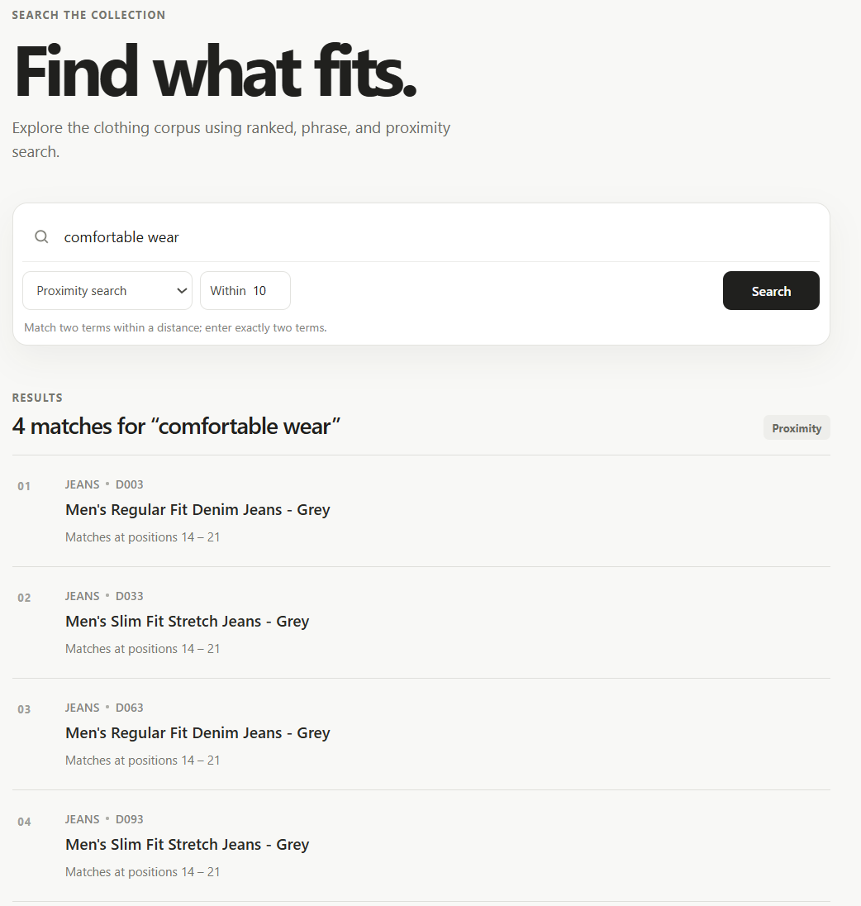

Testing for Words which are not in the Vocabulary
The word we tested for was “Hydrophobic”. For the sake of control, we additionally paired it with a known word, “leggings”.
- Ranked Search
  - 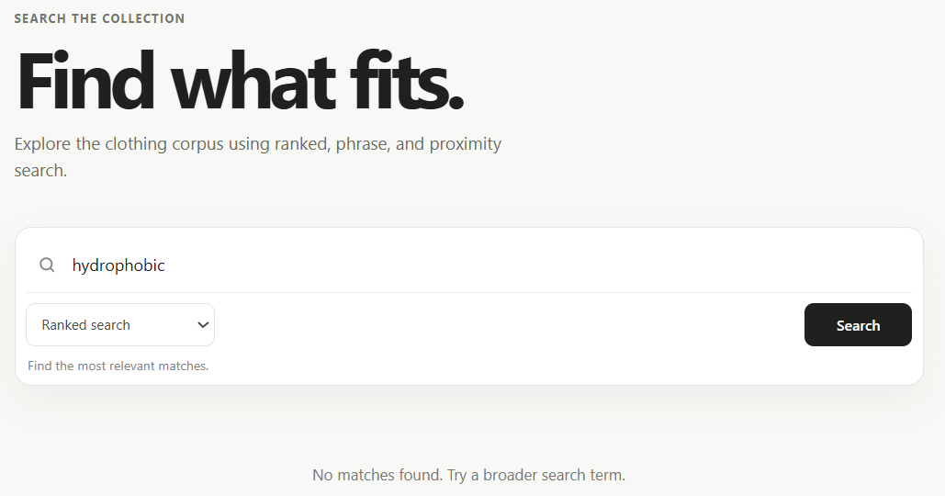
  - 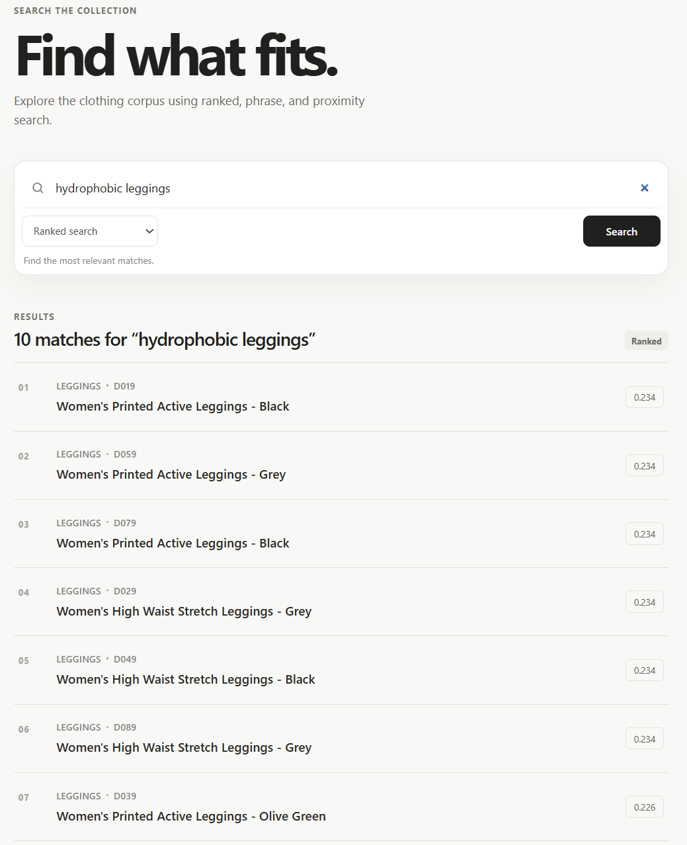
- Exact phrase queries:
  - 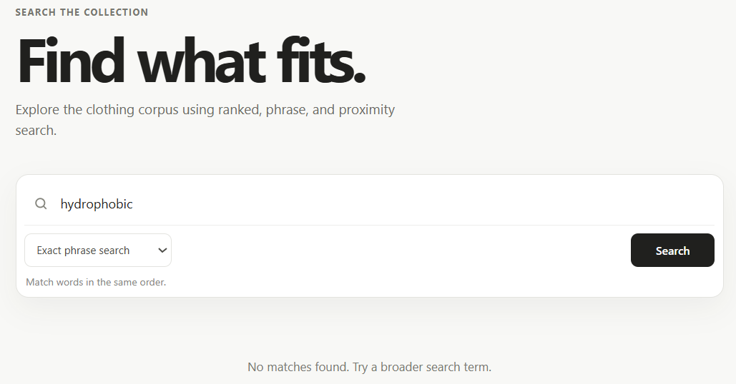
  - 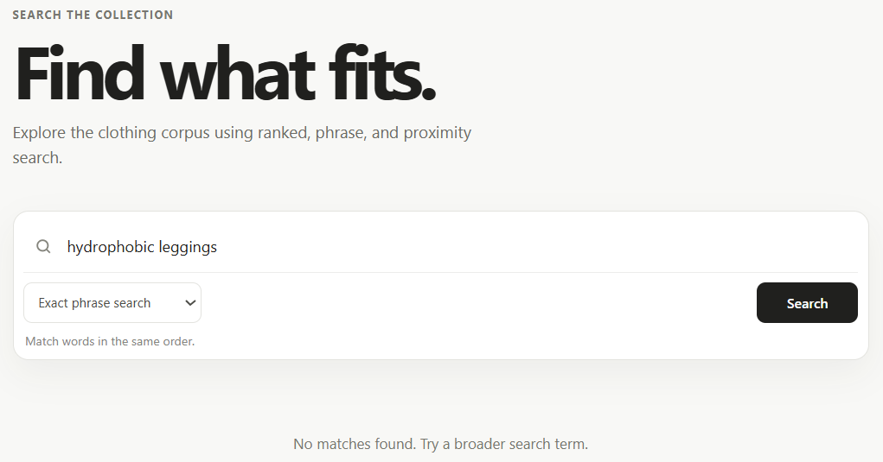
- Proximity Search:
  - Proximity = 20: 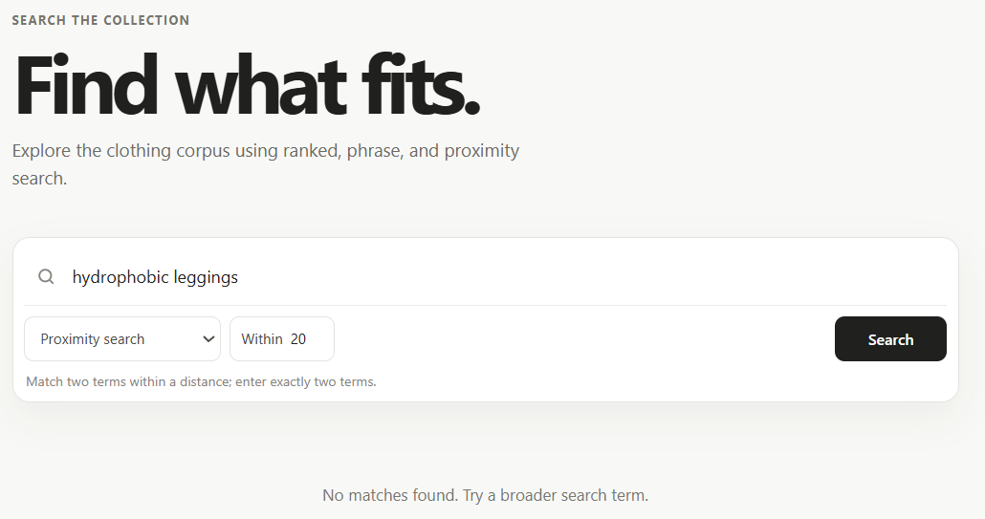
  - Proximity = 50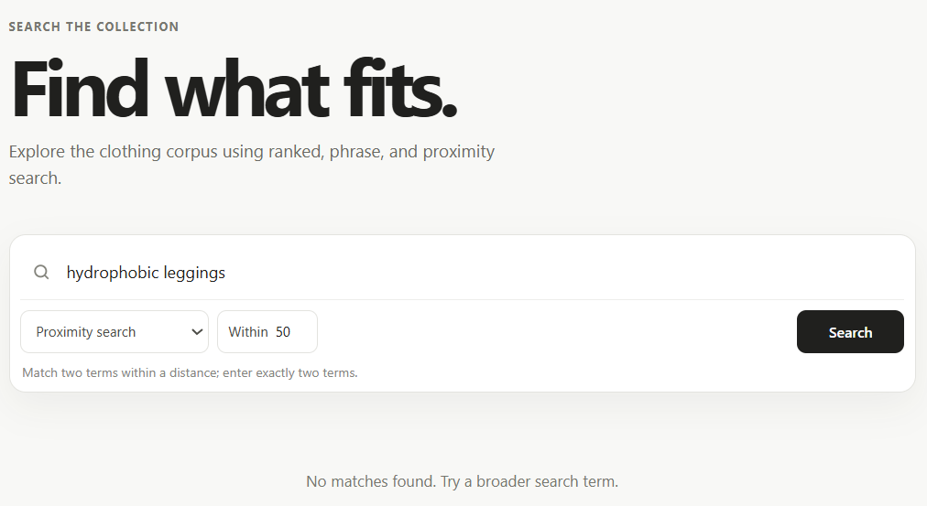

Impact of Positional Ordering on Query Results
- Ranked Search: Since the ranked search algorithm is ignorant of positional information and operates on a Bag-of-words (BoW) setup, ordering will not affect the query results. Nevertheless, an example of the same is given.
  - “Stretch Fit”: 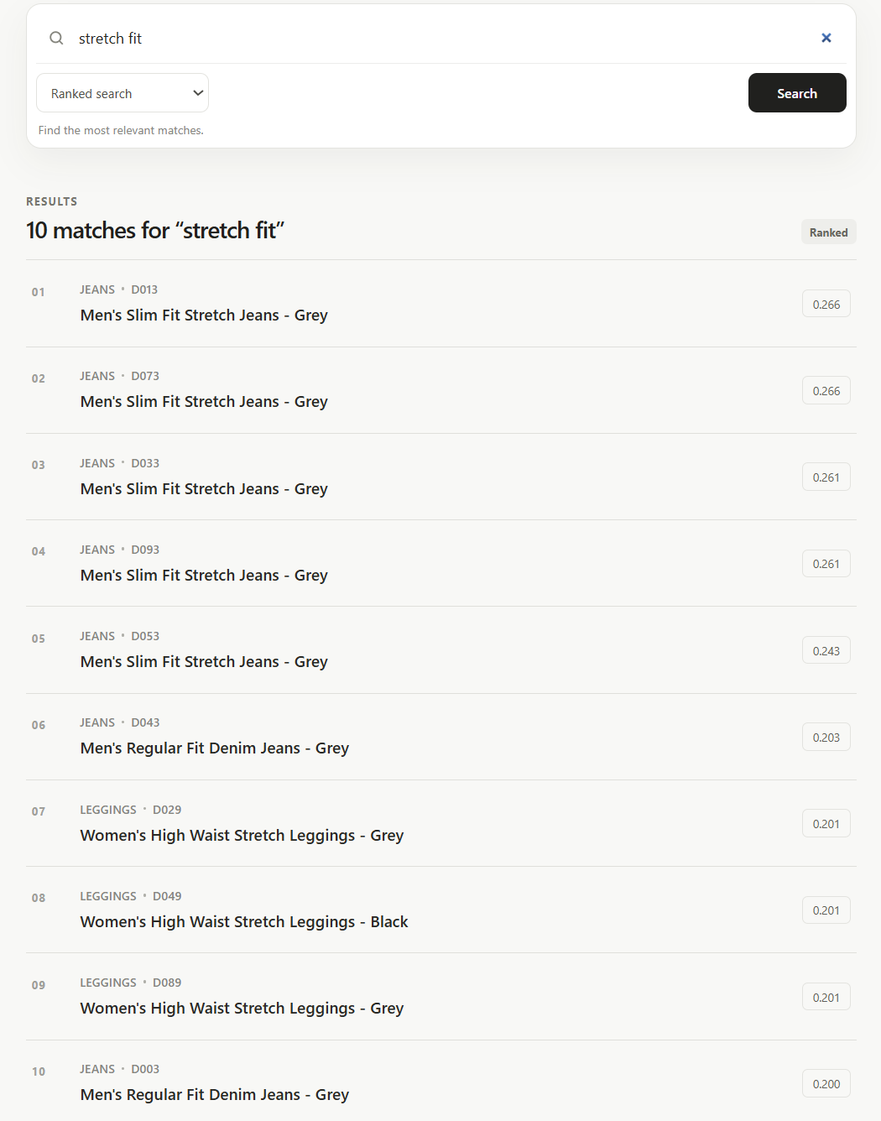
  - “Fit Stretch”: 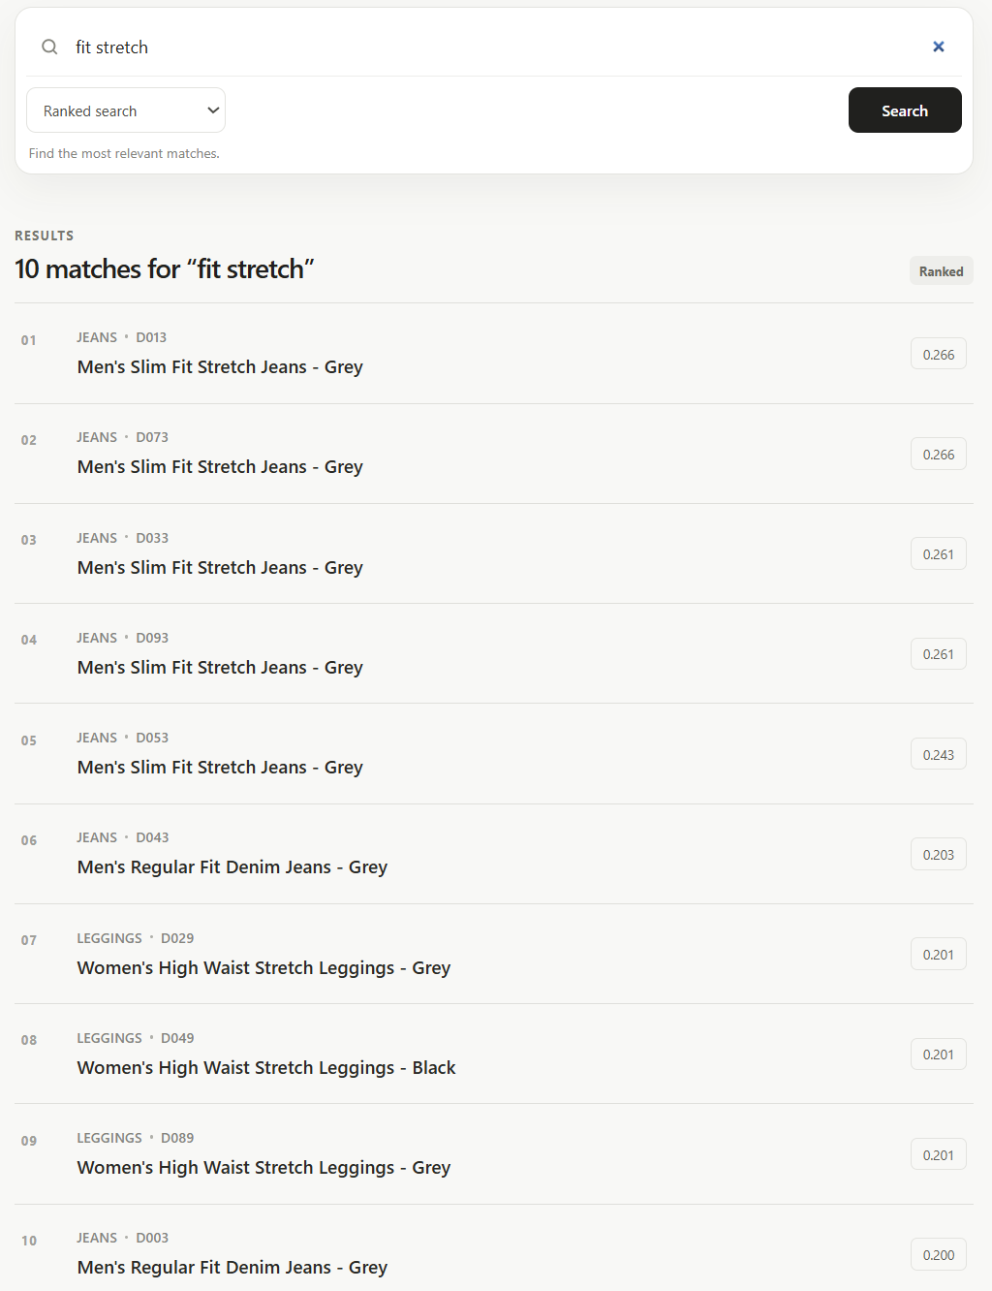
- Proximity Search: Here, the order matters because, according to the requirements, the system performs an ordered proximity search using the positional indexing, wherein the ordering of the terms must be followed strictly, along with the maximum proximity window. An example is shown below of the severity of the impact of the aforementioned ordering. Note: all results are not captured in the screenshot because of limitation of window size
  - “Indian WITHIN/3 wear” (100 matches):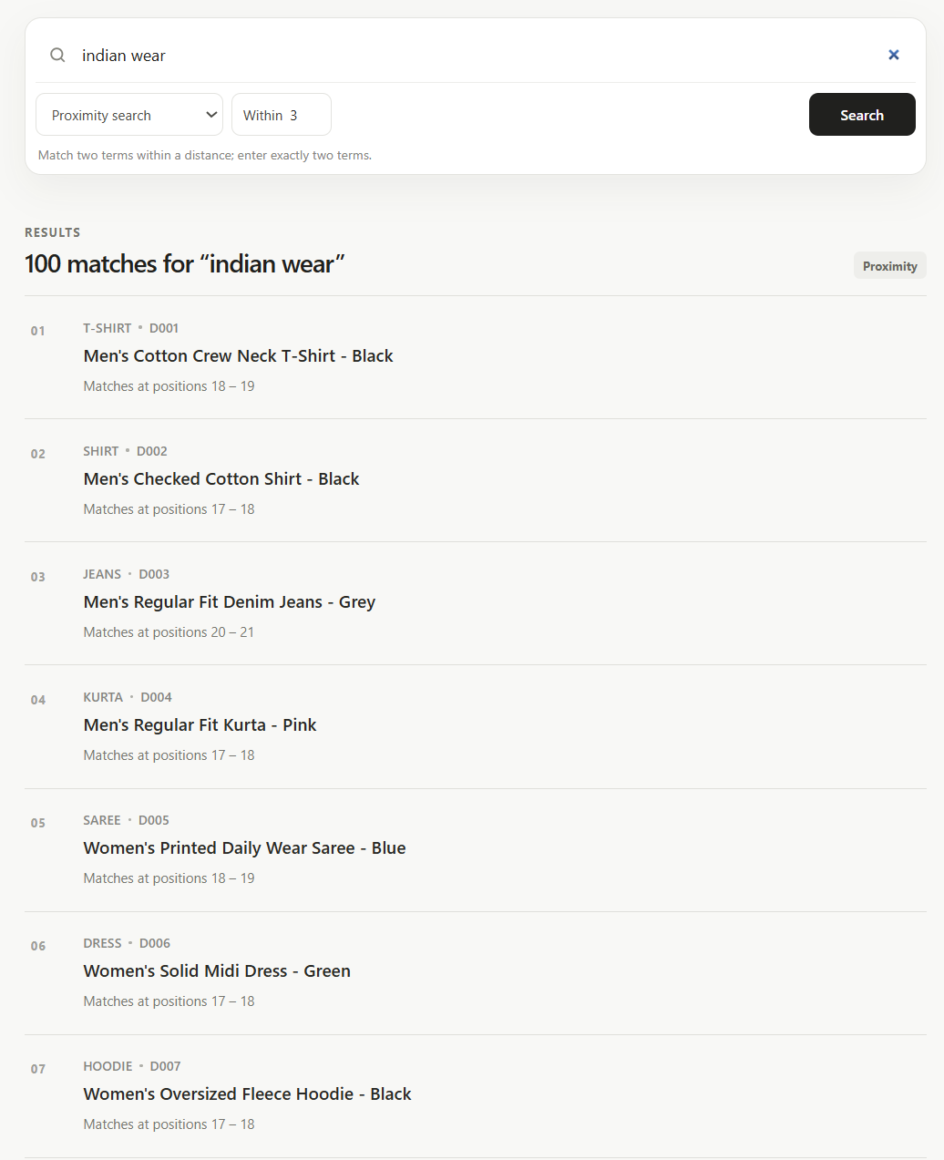
    - For the sake of completeness, proof is attached of one such occurrence (document D001)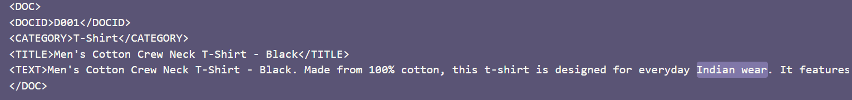
  - “Wear WITHIN/3 Indian” (0 matches):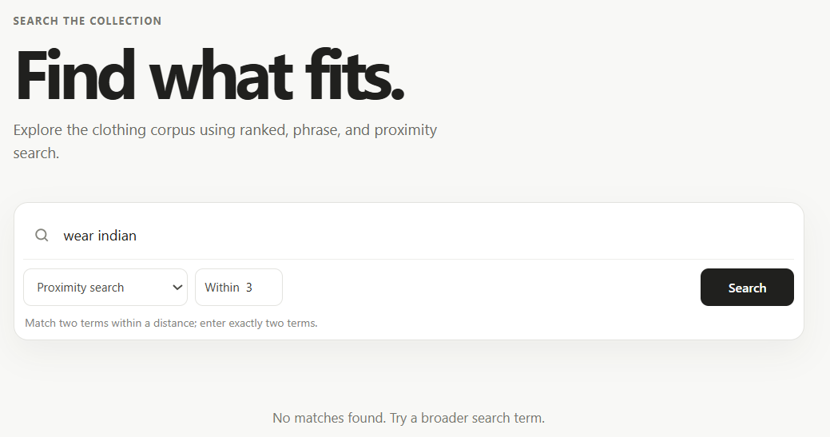
- Exact Phrase Queries: The reasoning here is the same as for “Proximity Search” as this is a special case of it where k=1. Nevertheless, examples are shown.
  - Stretch Fit (0 matches): 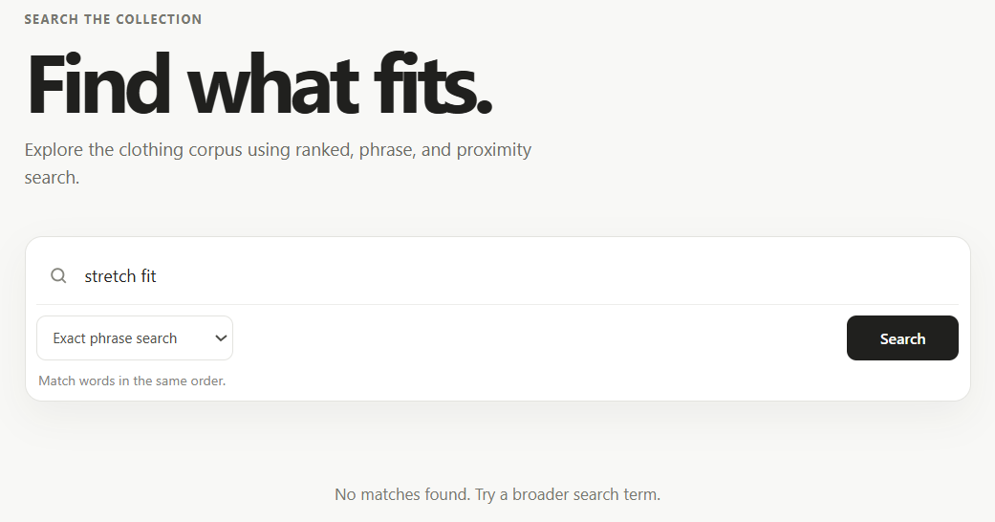
    - Proof for the same (directly searching the corpus’ txt file): 
  - Fit Stretch (5 matches):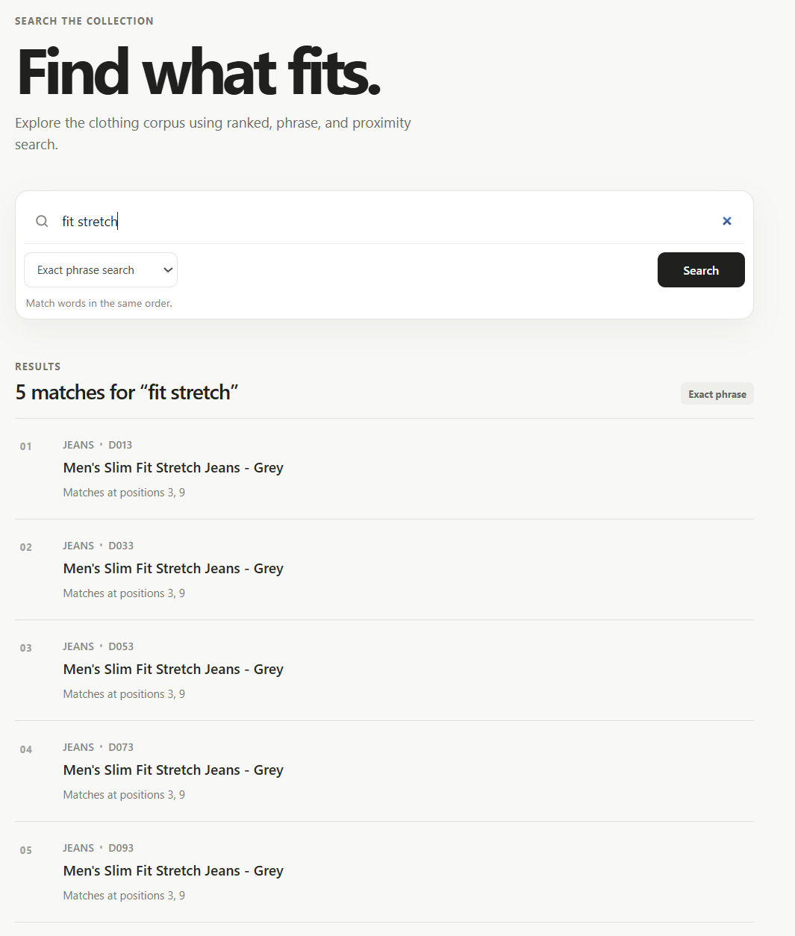
    - Proof for the same: 
    - Note that here there are 10 matches because each of the retrieved documents contains this phrase twice, as observable from “Matches at positions” having 2 indices for each of them.

